**Practical No. 5**

**Aim:** Service Endpoint

**Steps:**

Step 1: Create a new java application

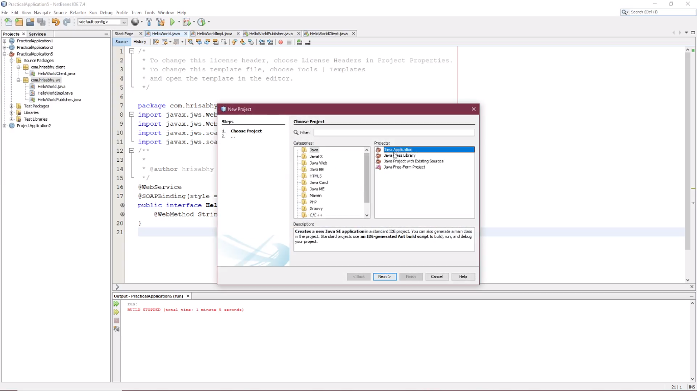

Step 2: Right-click on your project in the ‘Projects’ window. Select New > Java Interface. Enter the interface name as HelloWorld and click ‘Finish’ and type the following code.

// HelloWorld.java

import javax.jws.WebMethod;

import javax.jws.WebParam;

import javax.jws.WebService;

@WebService

public interface HelloWorld {

@WebMethod

String sayHello(@WebParam(name = "name") String name);

}

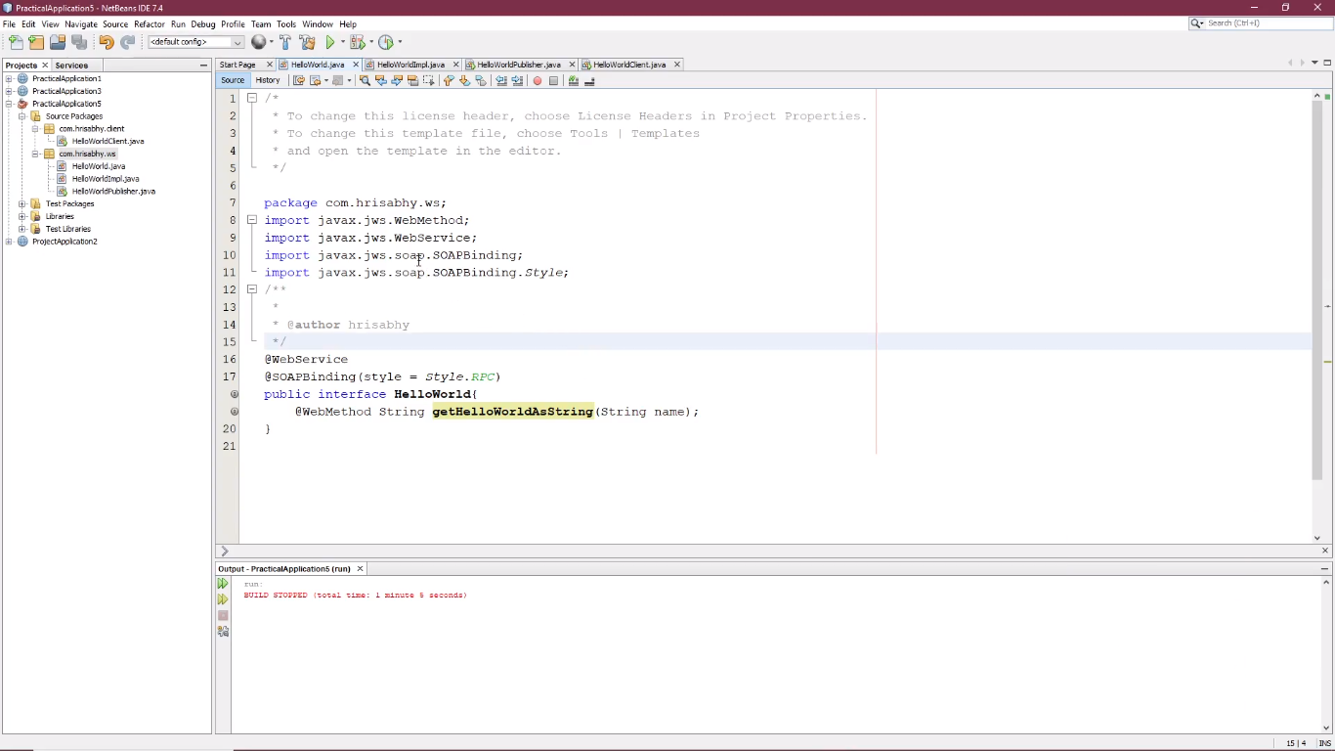

Step 3: Create HelloWorldImpl Class: Right-click on your project. Select New > Java Class. Enter the class name as HelloWorldImpl and click "Finish." Replace the content of the HelloWorldImpl.java file with the content from the previous response.

// HelloWorldImpl.java

import javax.jws.WebService;

@WebService(endpointInterface = "HelloWorld")

public class HelloWorldImpl implements HelloWorld {

@Override

public String sayHello(String name) {

return "Hello, " + name + "!";

}

}

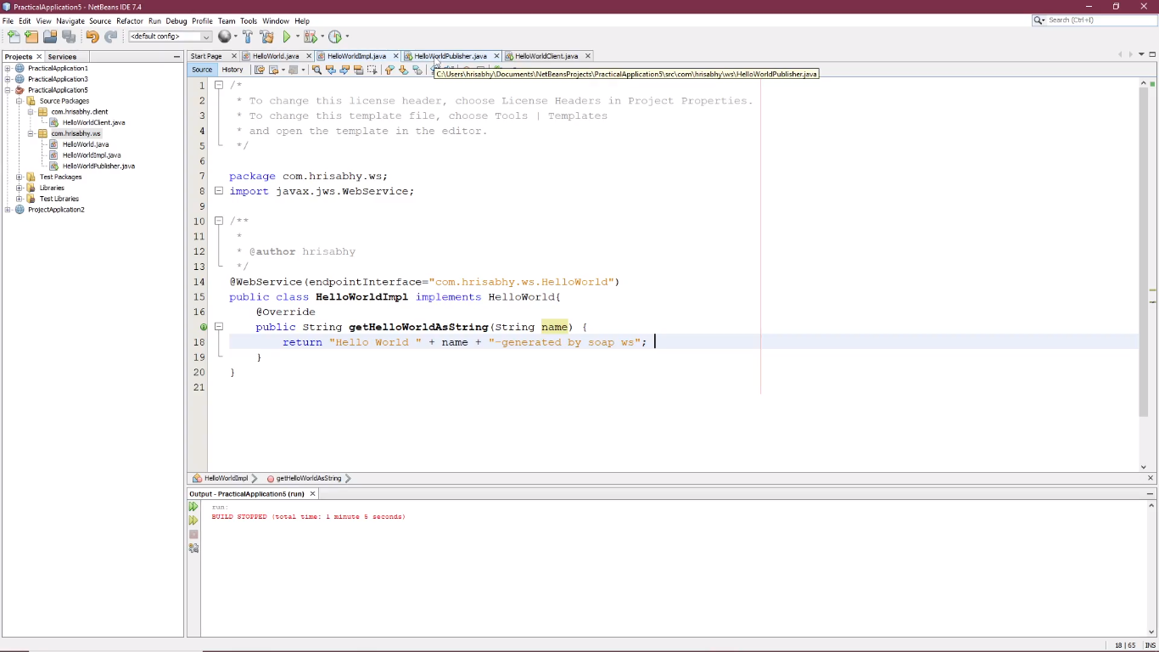

Step 4: Create HelloWorldPublisher Class: Right-click on your project. Select New > Java Class. Enter the class name as HelloWorldPublisher and click "Finish." Replace the content of the HelloWorldPublisher.java file with the content from the previous response.

// HelloWorldPublisher.java

import javax.xml.ws.Endpoint;

public class HelloWorldPublisher {

public static void main(String[] args) {

// Replace "http://localhost:8080/HelloWorld" with your desired endpoint URL

String endpointUrl = "http://localhost:8080/HelloWorld";

Endpoint.publish(endpointUrl, new HelloWorldImpl());

System.out.println("Web service published at: " + endpointUrl);

}

}

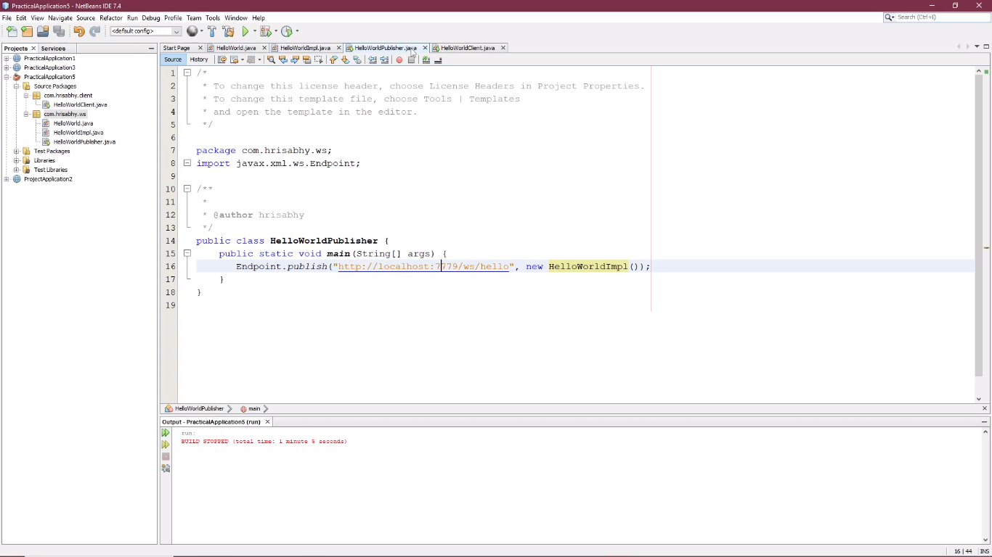

Step 5: Compile and Run compile all four Java files. Make sure the HelloWorldPublisher is running. Run the HelloWorldClient to test the web service.

